# Installing Drools on Tomcat

## Download drools-5.0-guvnor from the JBoss website at <http://www.jboss.org/drools/downloads.html>

## Unpack it, and copy the drools-guvnor.war file to the Tomcat webapps directory

## Download jboss_jsf_libs.zip from <http://download.jboss.org/drools/dependencies/jboss_jsf_libs.zip>

## Unpack it, and copy the 3 libraries to C:\Program Files\Apache Software Foundation\Tomcat 6.0\webapps\drools-guvnor\WEB-INF\lib

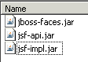

## Run <http://localhost:8080/drools-guvnor/> and you will get this login screen

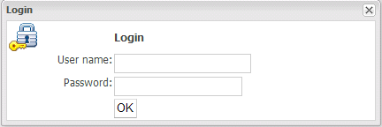

## Leave the ID and Password blank and just click the OK button

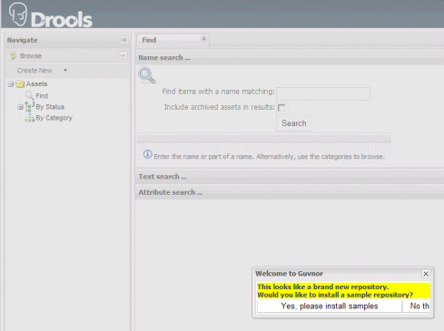

## Click on “Yes, please install samples”

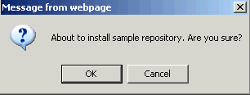

## Click on “OK” and you will get a confirmation that repository was installed successfully

You now have Drools running under Tomcat…